Installing and Configuring Redis

1. Get Latest Redis source from <https://download.redis.io/releases/redis-6.2.6.tar.gz>

1. Extract the components: tar -xzf redis-6.2.6.tar.gz

1. Browse to the directory using the cd redis-6.2.6 command

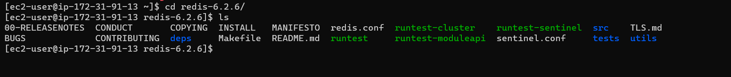

1. Execute sudo yum groupinstall ‘Development Tools’

1. Execute sudo yum install gcc make

Press y

1. Execute sudo make. This step takes some time. Please waitText

   Description automatically generated

At the end you should find the following message:

1. Execute sudo yum install tcl

1. Execute sudo make test. This step will take some time. Please wait. Once completed you should see this message. Incase you don’t see this message, **run this command again**.

1. Execute sudo make test install. This command will make redis commands available across the system. You can run redis commands from anywhere in your machine
2. Browse to /home/ec2-user/redis-6.2.6 and edit the redis.conf file

1. Start redis server with *redis-server redis.conf* command

1. A sample Spring Boot application has been provided at <https://github.com/musibs/spring-redis> to test the Redis connectivity. Build the application using mvn clean install command and run it in the server. It will publish messages to Redis.

1. Access the messages from redis server using redis-cli

